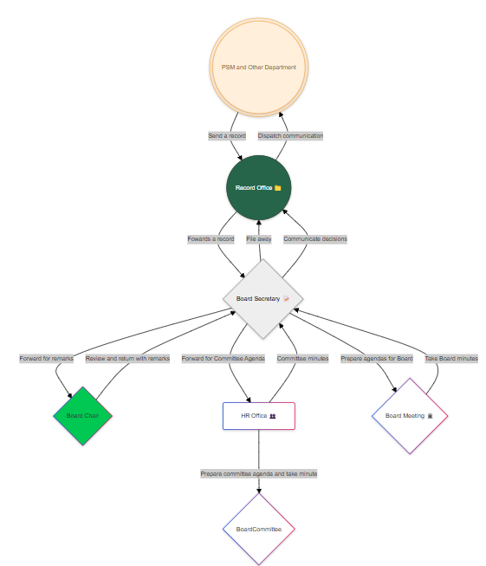Flowchart of Records Management

Implementation

Based on the document flow in this Records Management System (RMS), implementing a file system for electronic handling, including commenting on records by authorized actors, involves structuring processes around these steps. Here's how you can start coding for this:

**1. Identify Key Entities and Operations:**

From the flowchart, key entities are:

- Document Initiator (Other Departments)

- Records Office (Gateway)

- Board Secretary

- Board Chairperson

- HR Office

- Board Meeting

Each entity performs specific tasks (e.g., commenting, forwarding, recording). The system should allow for these entities to electronically upload, track, and comment on documents.

**2. Define Core Functionalities:**

- Document Handling: Ability to upload, store, and manage documents. Metadata such as document date, subject, and status (e.g., forwarded, under review) should be logged.

- Workflow Tracking: A system to track the flow of documents from initiation through to the final board decision.

- Role-Based Access Control (RBAC): Each user (e.g., Board Secretary, Chairperson) should have access only to the features necessary for their role, including comment privileges.

- Commenting and Remarks: Authorized personnel should be able to electronically comment on documents, akin to manual remarks. This can be done using a digital annotation or commenting feature.

- Notifications and Alerts: The system should notify relevant parties when action is needed (e.g., documents sent for remarks).

- Audit Trail: Record all actions (e.g., forwarding, commenting) for accountability.

- Document Dispatch: Final decisions should trigger automated notifications and dispatch processes back to the relevant agency.

**3. Suggested Workflow Implementation:**

Using a modular approach, each department and board member’s interaction with a document would follow predefined steps, ensuring a smooth flow of records.

1. Document Upload (by other departments) →

2. Receive and Record Metadata (Records Office) →

3. Forward to Board Secretary →

4. Comments and Remarks (Chairperson, Board Secretary) →

5. Forward for Agenda or Filing (HR Office/Board Meeting) →

6. Communicate Final Decision (Records Office) →

7. Dispatch to Initiator

**4. Technology Stack Suggestions:**

The following programming languages and frameworks can be used to implement the RMS based on the described operations:

1. Backend:

- PHP or Python (Django/Flask) for handling business logic, routing, and connecting to the database.

- Node.js (JavaScript) for real-time features like notifications and live updates on document status.

2. Frontend:

- JavaScript (React.js, Angular, or Vue.js) for building a user-friendly interface where authorized personnel can interact with the system (upload documents, comment, forward).

- jQuery/AJAX for seamless asynchronous operations (e.g., submitting forms without refreshing the page).

- HTML5/CSS for structuring the system’s interface.

3. Database:

- MySQL or PostgreSQL for securely storing document metadata, user roles, and tracking comments/actions.

- Use MongoDB if dealing with a variety of document formats (structured/unstructured).

4. Document Management:

- File Storage: A file system like AWS S3 or local file storage for securely storing documents.

- Version Control: Implement Git or a similar version control for documents, enabling the tracking of changes over time.

5. Security and Access Control:

- Implement OAuth 2.0 or JWT for secure authentication and authorization of users (ensuring only authorized actors comment or forward records).

- SSL Encryption for secure data transmission.

**6. Electronic Signatures/Comments:**

- Implement libraries like PDF.js for commenting on documents directly (if using PDFs) or use markup libraries for in-system annotation.

5. Next Steps:

- Design database schema that represents the flowchart entities and tracks document statuses.

- Create APIs that handle document operations (upload, commenting, forwarding).

- Integrate role-based authentication to ensure secure and authorized access.

- Test the Workflow: Test each step to ensure documents move correctly between entities and comments are recorded properly.

With this structure in place, the RMS can fully handle the described workflow electronically, mimicking the manual process of commenting and managing documents.